

TxDOT User Manual

Contents

Introduction 2

1. Step 1 2

2. Step 2 2

3. Step 3 2

4. Result 2

# Introduction

TxCRCP-ME was developed under research project 0-5832, "Develop Mechanistic/Empirical Design for CRCP." This is a application that determines CRCP performance (punch-outs per mile) based on user inputs for location, traffic, concrete properties and support layers.

# How to use

TxCRCP-ME can be downloaded at <https://github.com/iDataVisualizationLab/TxDOT/tree/main/dist>

Use can use the portable version or the setup version. The current version is 2.6 and available at:

* [Portable](https://github.com/iDataVisualizationLab/TxDOT/blob/main/dist/TxCRCPME%202.6.exe)
* [Setup](https://github.com/iDataVisualizationLab/TxDOT/blob/main/dist/TxCRCPME%20Setup%202.6.exe)

# Step 1

button.

In Step 1, the user will be required to fill in general information about the project (Figure 1). The “District” field is required to calculate the temperature of the project area.

Figure . Step 1 interface

icon to open the map and select on it (Figure 2, Figure 3).

|  |  |
| --- | --- |
| Map  Description automatically generated  Figure . District map. | Figure . County map |

to go to the Step 2.

# Step 2

In Step 2, there are 3 fields need to be filling in.

* Design life (years): need to be not less than 1
* Total number of lanes in one direction: between 1 and 10
* Total design traffic in on direction: between 1 and 500

button.

Figure . Step 2 interface

to go to the Step 3.

# Step 3

Step 3 require the layer information: Subgrade and Treatment Information and Base Layer Information.

* Soil classification of subgrade: select one of 15 options (GW, GP, GM, etc. )
* Plasticity Index (PI): a measure of the plasticity of a soil need to be positive
* Subgrade treatment: select one of 7 options
* Subgrade treatment thickness (in.): need to be not less than 1
* Base type: choose between CRB, HMA and ASB
* Base layer thickness (inches): currently this field will automatically adjust base on the Base type input

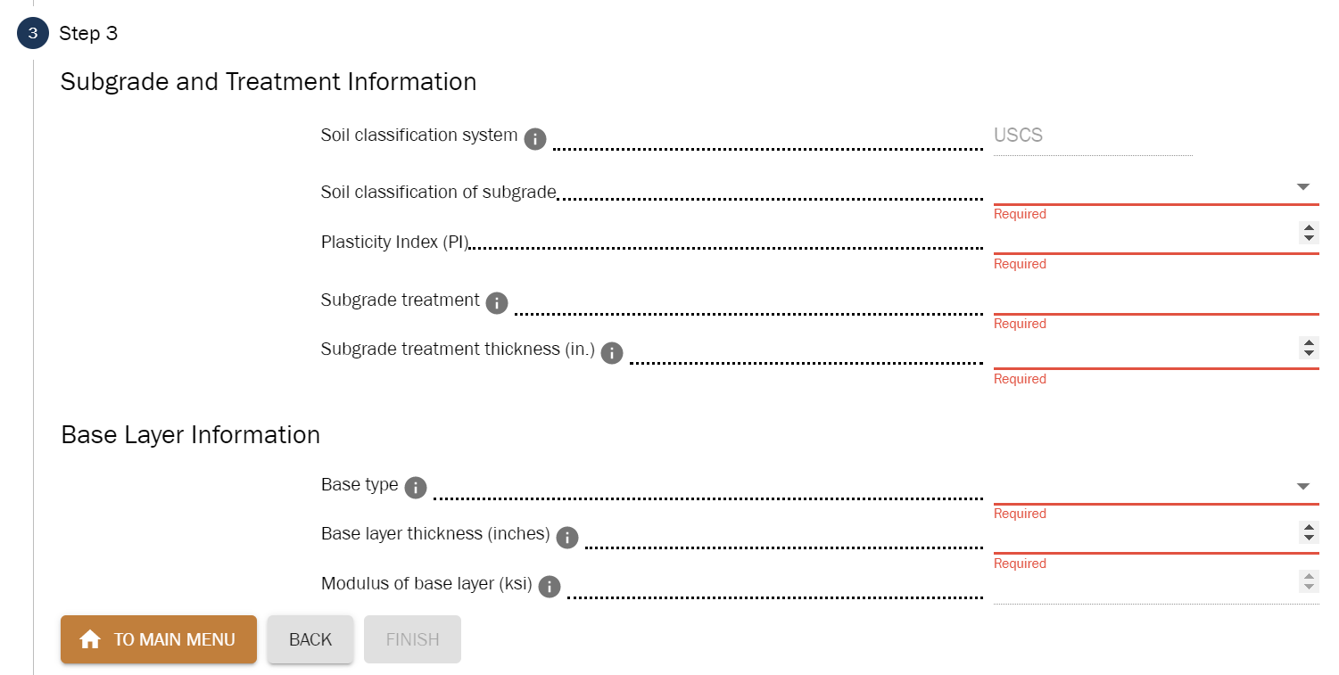

Figure . Step 3 interface

to go to the Result.

# Result

After finish all the previous step, the result will be displayed on this stage where input data is the user input and analysis result is the application calculation.

button to clear all input data and go back to Step 1.

button.

button

button.

Figure . Example result